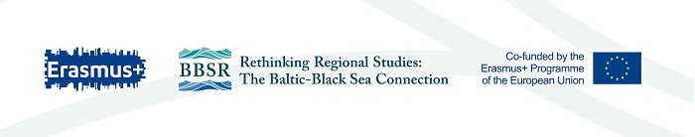
The project lasted from 2017 until 2021.

The project's goal was to modernise regional studies at the Ukrainian partner universities, internationalise their study offer and provide support in implementing international projects.

The project achieved its main goals, which were:
- creation of an English-language MA programme (the first corresponding to Bologna principles) on Baltic and Black Sea Region Studies at Ivan Franko National University of Lviv thereby modernising regional studies in Ukraine; overall 22 new courses were developed in the four Ukrainian universities;
- creation of modules on regional studies at other Ukrainian universities, embedded in the international relations studies;
- new knowledge and skills in regional studies and international relations;
- facilitating innovative ways as well as the quality of teaching and learning at Ukrainian universities by the purchase of equipment, including smartboards, anti-plagiarism software, access to online resources, and thematic books;
- in addition to equipment, an adequate training was provided for both teachers and students on academic writing and integrity, plagiarism, innovative teaching methods, blended courses etc.

Among other achievements:
- the students of Ukrainian universities have received international learning experience both at a winter school in Estonia as well as in Mariupol;
- the project has intensified other cooperation between the Ukrainian partners themselves and with the EU partners;
- thanks to the project, decrees have been adopted at IFNUL about the international cooperation and projects; project results have been disseminated on the project webpage and Facebook page, at different conferences and meetings, as well as regional newspapers and TV.

The project has contributed to the internationalisation of curricula at partner universities, more effective use of online learning methods, raised awareness of both teachers and students on plagiarism.

