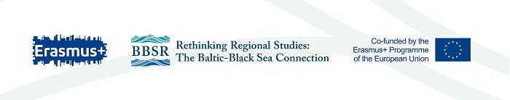
Application form for admission to Master Programme
This application form for admission to a Master Programme is required for all candidates
LAST NAME, First name(s) ___________________________________
Nationality: ____________________________________Date of birth: ______________
Country of residence:_______________________________
Postal Address: _______________________________________________________________________
E-mail address: ___________________________ Telephone number(s): ____________________
Degrees earned previously:
Completion date | Degree | University or other  institution of higher  education | Country
Level studies in progress:
Expected completion  date | Expected status at the end of the current  academic year | University or other  institution of higher  education | Country
Other programs completed:
Completion date | Title | Institution | Country

Please indicate the time of arrival to have the entrance interview and submit the originals of the documents (Terms of entrance interviews are from 16 July till 20 August 2019)
From_____________________________________ to_______________________________
Publications ( if any) __________________________________________________
The following documents must be submitted with the application form for admission to :
1) this form, completed and signed
2) Copy of your education certificate obtained with grades as well as academic transcript.
3) Copy of your education certificate obtained with grades as well as academic transcript (translated into English or Ukrainian)
4) English Language Certificate (min.B2 level on the CEFR scale) if available.
5) Copy of your passport first page.
6) Motivation letter (max. 1 page)

I hereby confirm that all information I have provided in this form is complete and accurate.
Place and date: ______________________________
Signature: __________________________________

